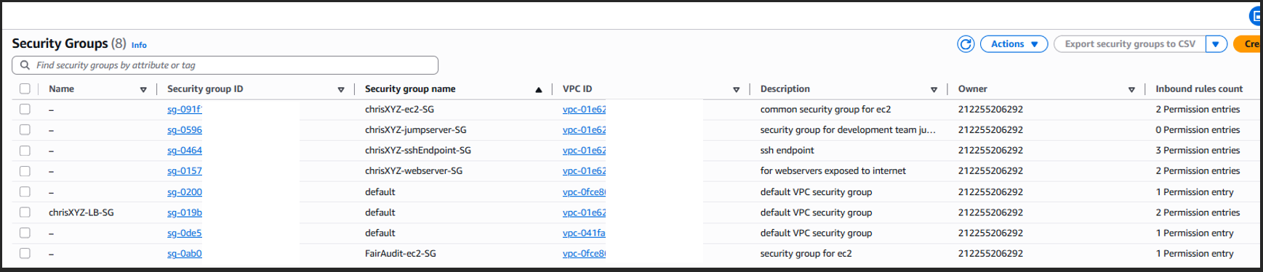

ChrisXYZ - Security Group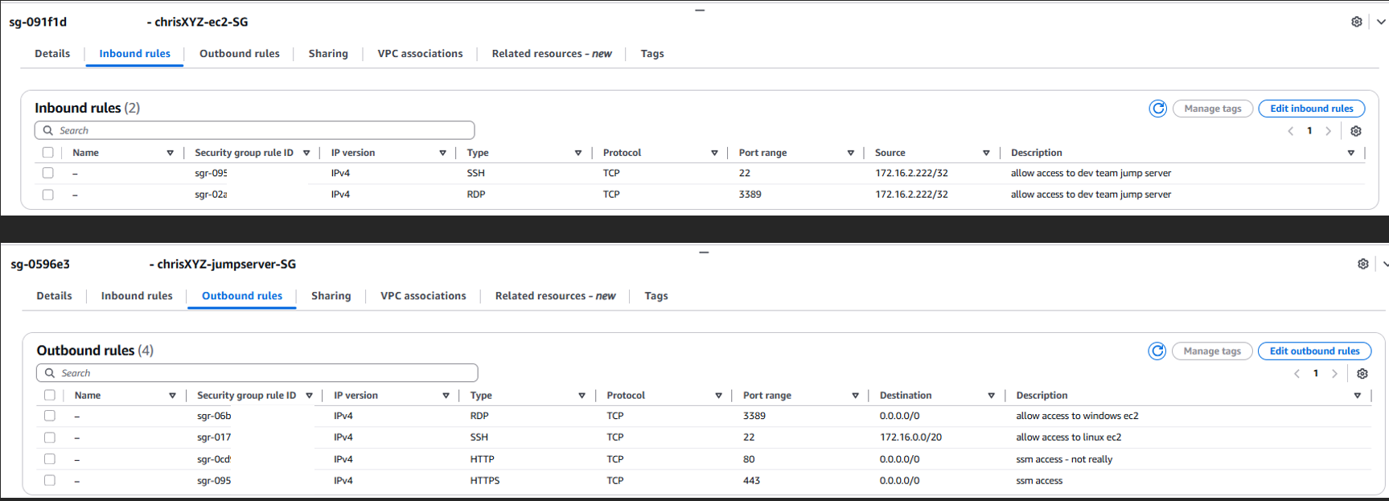

Webserver-SG should have SSH<-0.0.0.0/0 for EC2 Instance connect feature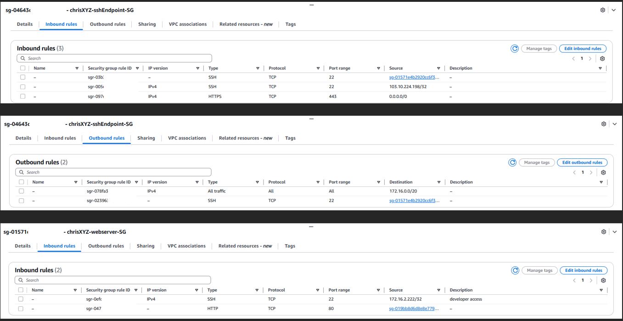
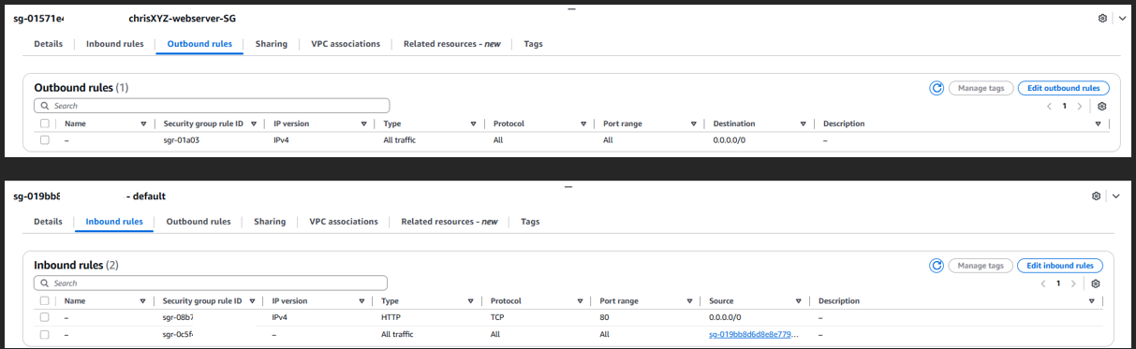
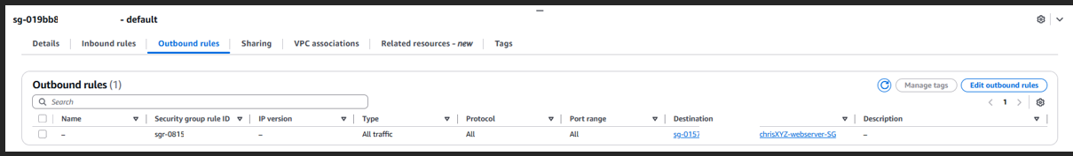
FairAudits – Security Group
